

**Name:** Muhammad Faizan

**Roll No:** 036

**Section:** BSDS-3A

**Code:**

TASKS_FILE = "all_tasks.txt"

tasks_list = []

while True:

print("Your tasks right now:", tasks_list)

what_to_do = input("Do you want to add, view, remove or quit? ").lower()

if what_to_do == "add":

newtask = input("Write YOUR task: ")

priority = input("What is the priority level (low, medium, high): ")

tasks_list.append(newtask)

print("task was added")

with open(TASKS_FILE, "a") as tasks:

tasks.write(f"{newtask} priority level: {priority}\n")

print("Task added")

elif what_to_do == "remove":

taskname = input("Which task to remove? write exact: ")

if taskname in tasks_list:

tasks_list.remove(taskname)

print("removed")

else:

print("task not found")

elif what_to_do == "view tasks":

tasks = tasks.read()

print(tasks)

elif what_to_do == "quit":

print("ended")

break

else:

print("wrong answer")

**Output:**

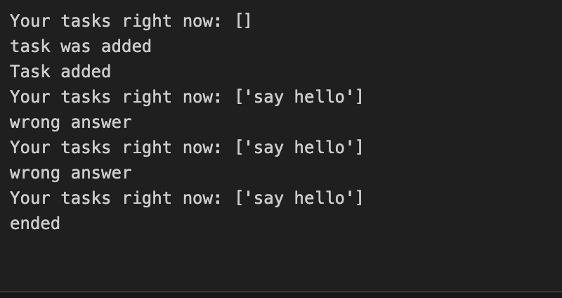

**Explanation:**

The code starts by setting up a file called all_tasks.txt where the tasks will be stored. It also creates an empty list called tasks_list to keep track of the tasks.

### The Main Loop

The program enters a loop that runs continuously, asking you what you want to do with your tasks. Here’s the first part of the loop:

while True:

print("Your tasks right now:", tasks_list)

what_to_do = input("Do you want to add, view, remove or quit? ").lower()

It shows the current tasks in tasks_list and asks you to choose one of the following options:

* Add a task
* View tasks
* Remove a task
* Quit the program

The input method takes your response, and .lower() ensures the input is case-insensitive (so you can type "add", "Add", or "ADD" and it will still work).

### Adding a Task

If you choose "add", it will ask for the task name and its priority level. After that, it adds the task to the tasks_list and writes it to the all_tasks.txt file.

Here's what it does:

if what_to_do == "add":

newtask = input("Write YOUR task: ")

priority = input("What is the priority level (low, medium, high): ")

tasks_list.append(newtask)

print("task was added")

with open(TASKS_FILE, "a") as tasks:

tasks.write(f"{newtask} priority level: {priority}\n")

print("Task added")

* First, it asks you for the task description and its priority.
* Then, the task gets added to the tasks_list.
* The task, along with its priority, is written to the all_tasks.txt file (using the "append" mode so it doesn't overwrite existing tasks).

### Removing a Task

If you choose "remove", the program asks you to type the exact name of the task you want to remove. It checks if the task exists in the tasks_list, and if so, removes it. If the task is not found, it lets you know.

Here’s how it works:

elif what_to_do == "remove":

taskname = input("Which task to remove? write exact: ")

if taskname in tasks_list:

tasks_list.remove(taskname)

print("removed")

else:

print("task not found")

* If the task is in the list, it gets removed.
* If the task doesn't exist in the list, it prints a "task not found" message.

### Viewing Tasks

If you choose "view tasks", the program will try to read and display the contents of all_tasks.txt. However, there's an issue here — the file is not opened in a way that lets it print the tasks. It should open the file and read it before trying to display the tasks. Here’s the current code:

elif what_to_do == "view tasks":

tasks = tasks.read()

print(tasks)

* It reads the contents of all_tasks.txt, but the file should have been opened first with open() before trying to read it. There’s a small bug here.

### Quitting the Program

If you type "quit", the program prints "ended" and breaks out of the loop, effectively stopping the program.

elif what_to_do == "quit":

print("ended")

break

### Handling Incorrect Inputs

If you type anything other than "add", "view tasks", "remove", or "quit", the program will print "wrong answer" and ask again.

else:

print("wrong answer")

### Summary

So, the program lets you manage your tasks with the following options:

* **Add a task**: You type in a task and its priority, and it gets added to both the list and the file.
* **Remove a task**: You specify the exact name of the task, and it gets removed from the list.
* **View tasks**: Displays the tasks (but there’s a small issue with reading the file).
* **Quit**: Ends the program.

This simple task manager is a great way to keep track of things, though it does need a minor fix for viewing tasks correctly.